**Berry Delicious Smoothies**

Prep Time: 5 mins

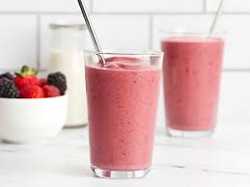Total Time: 5 mins

Servings: 4

Yield: 4 cups

**Ingredients**

Original recipe yields 4 servings

* 2 cups frozen mixed berries
* 1 banana, sliced
* 1 cup strawberry-flavored yogurt
* 1 cup milk
* ½ teaspoon white sugar (Optional)

**Directions**

1. Place mixed berries, banana, strawberry yogurt, milk, and sugar in a blender; cover and blend until smooth. Pour into glasses; serve.

**Nutrition Facts**(per serving)

|  |  |
| --- | --- |
| 118 | Calories |
| 2g | Fat |
| 24g | Carbs |
| 5g | Protein |